St. PETER’ S COLLEGE OF ENGINEERING AND TECHNOLOGY
AVADI , CHENNAI – 600054

MANDATORY DISCLOSURE

1 | AICTE File No | F . NO . 06 / 05 / TN / E& T / 2008 / 73
1 | Date & Period of last approval | 20. 05. 2024 , 1 - 43660343363/  2024
2 | Name of the Institution | St .Peter’s College of Engineering and Technology
2 | Address of the Institution | College Road , Avadi , Chennai – 6 0 0 0 5 4 .
2 | City & Pin Code | Avadi , Chennai – 600054
2 | State / UT | Tamilnadu
2 | Longitude & Latitude | Latitude - 13 , 7 , 13  Longitude - 80 , 6 , 36
2 | Phone Number with STD Code | 044 – 26558091
2 | Fax number with STD Code | 044 – 26558092
2 | Office hours at the Institution | 9. 00 am – 5 . 00 pm
2 | Academic hours at the Institution | 8. 15 am – 4 . 00 pm
2 | Email | principal@spcet.ac.in
2 | Website | www.spcet.ac.in
2 | Nearest Railway Station  (distance in Km ) | Annanur Railway Station - 1 km
2 | Nearest Airport ( distance in Km ) | Meenambakkam , Chennai -  20 Kms
3 | Type of Institution | Private – Self Financed
3 | Category ( 1 ) of the Institution | Non Minority
3 | Category ( 2 ) of the Institution | Co - Education
4 | Name of the organization running the Institution | Lakshmi Saraswathi Educational Trust
4 | Type of the organization | Trust
4 | Address of the organization | No : 621 , SIRE Mansion , Khivraj Motors Building , Annasalai ,  Chennai – 600006 .
4 | Registered with | Sub Registrar Office, Anna Nagar
4 | Registration date | 1998 / 92 , 05 . 11 . 1992
4 | Website of the Organization | www.spcet.ac.in

5 | Name of the affiliating University/ Board | Anna University
5 | Address | Sarder Patel Road, Guindy,  Chennai - 600025
5 | Website | www.annauniv.edu
5 | Latest Affiliation period | 2024 - 2025
6 | Name of the Principal / Director | D r. S. Poornachandra
6 | Exact Designation | Principal
6 | Phone No with STD Code | 044 – 26558092
6 | Fax No with STD Code | 044 – 26558091
6 | Email | principal@spcet.ac.in
6 | Highest Degree | Ph .D
6 | Field of Specialization | Medical Signal Processing

- Governing Council Members

S.NO | NAME | POSITION | QUALIFICATION | PRESENT DESIGNATION/OCCUPATION
1 | Dr. BANUMATHI T | CHAIRMAN | MBBS - DGO - MEDICINE | CHAIRPERSON
2 | Dr. S. POORNACHANDRA | MEMBER SECRETARY | Ph.D -Faculty of Information and Communication Engineering | PRINCIPAL
3 | Dr. LASYA T | MEMBER | MBBS- FRCR - MEDICINE | DOCTOR
4 | Dr. NAMRATHA T | MEMBER | MBBS - MEDICINE | DOCTOR
5 | Mr. K. PRABU | MEMBER | B.A., D.Pharm | SECRETARY
6 | Prof. RAJAMANICKAM K | MEMBER | M.A - ECONOMICS | RETIRED PROFESSOR
7 | Dr. S. GOPI | DOTE NOMINEE | Ph. D | ASSISTANT DIRECTOR(PLANNING),DIRECTORATE OF TECHNICAL EDUCATION, CH-25
8 | Dr. M.A. BHAGYAVENI | ANNA UNIVERSITY NOMINEE | Ph.D -Faculty of Information and Communication Engineering | PROFESSOR,CEG CAMPUS, ANNA UNIVERSITY,  CH-25
9 | Mr. R. SRINIVASAN | MEMBER-INDUSTRIAL EXPERT | B.Sc, B.Tech, MBA, PGDEM | FOUNDER - CHIEF TECHNICAL OFFICER, (VAST PRO TECHNOLOGIES PRIVATE LTD), CHENNAI
10 | Mr. S. SABARISH | ADMINISTRATIVE MEMBER | B. Com (CA) | AUDIT OFFICER
11 | Dr. A. SWARNALATHA | MEMBER | Ph.D -Faculty of Information and Communication Engineering | DEAN – CURRICULAM DEVELOPMENT CENTRE
12 | Dr. S. THENESH KUMAR | MEMBER | Ph.D -Faculty of Chemical Engineering | DEAN – STUDENT AFFAIRS AND SCHOLARSHIP
13 | Dr .K. PURUSHOTHAMAN | MEMBER | Ph.D - Faculty of Mechanical Engineering | CONTROLLER OF EXAMINATIONS
14 | Dr. P. PREETHY REBECCA | MEMBER | Ph.D -Faculty of Information and Communication Engineering | COORDINATOR – INTERNAL QUALITY ASSURANCE CELL
15 | Dr .M. CHINNAPANDIAN | MEMBER | Ph.D - Faculty of Mechanical Engineering | DEAN- RESEARCH AND DEVELOPMENT

- Planning & Monitoring Board

S.NO | NAME | POSITION | QUALIFICATION | PRESENT DESIGNATION/OCCUPATION
1 | Dr. S. POORNACHANDRA | CHAIRMAN | Ph.D -Faculty of Information and Communication Engineering | PRINCIPAL
2 | Mr. K. PRABU | MEMBER | B.A., D.Pharm | SECRETARY
3 | Mr. R. SRINIVASAN | MEMBER | B.Sc, B.Tech, MBA, PGDEM | FOUNDER - CHIEF TECHNICAL OFFICER (VAST PRO TECHNOLOGIES PRIVATE LTD), CHENNAI- INDUSTRIAL EXPERT
4 | Mr. NEELA KANDAN MANI | MEMBER | B.E, M.TECH, Ph.D | VICE PRESIDENT, GROUP DELIVERY HEAD, TECH MAHINDRA
5 | Dr. K. PURUSHOTHAMAN | MEMBER | Ph.D - Faculty of Mechanical Engineering | CONTROLLER OF EXAMINATIONS
6 | Dr. M.CHINNAPANDIAN | MEMBER | Ph.D - Faculty of Mechanical Engineering | DEAN- RESEARCH AND DEVELOPMENT
7 | Dr. V.B.M .SAYANA | MEMBER | Ph.D - Faculty of Civil Engineering | PROFESSOR
8 | Dr. THENESH KUMAR S | MEMBER | Ph.D - Faculty of Chemical Engineering | DEAN – STUDENT AFFAIRS AND SCHOLARSHIP
9 | Dr. THARANI VIMAL | MEMBER | Ph.D - Faculty of Information Technology | PROFESSOR & HEAD
10 | Mrs. S. SRIRANJINI | MEMBER | Faculty of MBA | TRAINING AND PLACEMENT
11 | Ms. V. S. VEENA | MEMBER | Faculty of Electrical & Electronics Engineering | HOD - INCHARGE
12 | Mrs. MOHANAPRIYA | MEMBER | Faculty of Chemistry department | I ST YEAR HOD ,SCIENCE AND HUMANITIES
13 | Dr. A. SWARNALATHA | MEMBER | Ph.D -Faculty of Information and Communication Engineering | DEAN - CDC
14 | Dr. P. PREETHY REBECCA | MEMBER | Ph.D - Faculty of Computer Science and Engineering | COORDINATOR - IQAC
15 | Dr. B.A. GOWRI SHANKAR | MEMBER | Ph. D - Faculty of Bio technology | PROFESSOR & HEAD
16 | Dr. SHADRACH JEYA SEKARAN | MEMBER | Ph.D - Faculty of Mechanical Engineering | PROFESSOR & HEAD
17 | Dr. C. EVANGELINE | MEMBER | Ph.D - Faculty of MBA | HOD

- Organizational Chart

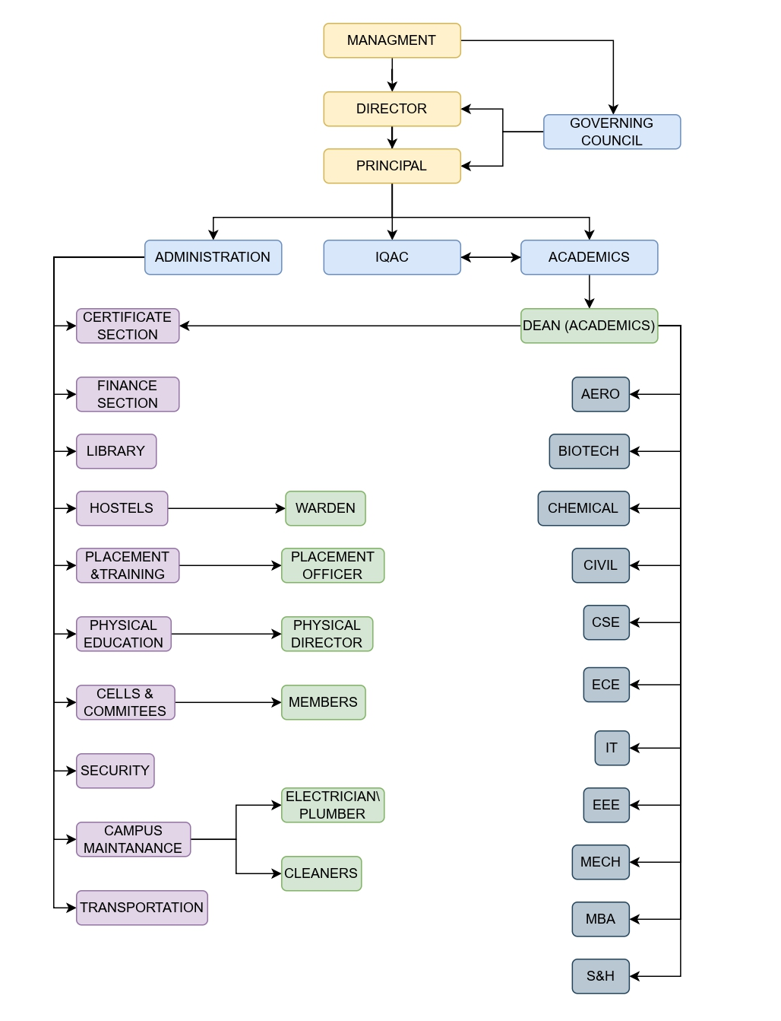

1 0 | Student feedback mechanism on  Institutional Governance / faculty performance | Feedback of the students are  obtained every semester regarding Institutional Governance / Faculty  performance separately .
1 1 | Grievance redressal  mechanism for faculty, staff and students | A grievance cell is formed with  convene r , members of staff and  students to look into the grievances of students and staffs

1 2 Name of the courses with intake

S. N o | DEGREE & BRANCH | APPROVED INTAKE
0 1 | B . TECH . – ARTIFICIAL INTELLIGENCE AND DATA SCIENCE | 6 0
0 2 | B . T E C H – BIOTECHNOLOGY | 6 0
0 3 | B . T E C H – CHEMICAL ENGINEERING | 3 0
0 4 | B.E - CIVIL ENGINEERING | 30
0 5 | B . E – COMPUTER SCIENCE AND ENGINEERING | 120
06 | B . E . – ELECTRICAL AND ELECTRONICS ENGINEERING | 3 0
0 7 | B . E . – ELECTRONICS AND COMMUNICATION ENGINEERING | 6 0
0 8 | B . T E C H – INFORMATION TECHNOLOGY | 120
0 9 | B . E . – MECHANICAL ENGINEERING | 3 0
10 | M. E . – STRUCTURAL ENGINEERING | 2 4
11 | M B A – MASTER OF BUSINESS ADMINISTRATION | 12 0
12 | M. E. – COMPUTER SCIENCE AND ENGINEERING | 9
TOTAL INTAKE |  | 693

13 . Admission Quota

Degree | : |  | ENGINEERING AND TECHNOLOGY ( B . E . / B. Tech )
Entrance Test /  Admission Criteria |  |  | No Entrance test in Tamilnadu.  Admission based on the marks obtained in  +2 Examinations ( Physics + Chemistry + Mathematics )
Course Fees |  |  | R s . 50 , 000 / - as per Govt norms ( Govt Quota)  R s . 85 , 000 / - as per Govt norms ( Mgt Quota)

Degree | : | ENGINEERING AND TECHNOLOGY ( M . E )
Entrance Test /  Admission Criteria |  | B . E . / B . Tech from a recognized university. Admission based on  TANCET and CET Entrance Score
Course Fees |  | R s . 5 0 , 0 0 0 / - as per Govt norms

Degree | : | MASTER OF BUSINESS ADMINISTRATION
Entrance Test /  Admission Criteria |  | A pass in any Bachelor Degree ( 3 Years ) from a recognized university. Admission based on TANCET and CET Entrance Score
Course Fees |  | R s . 3 5 , 0 0 0 / - as per Govt norms
1 4 . Details of faculty Strengths

S. No | DEGREE & BRANCH | No. of Faculty Member
01 | B . TECH . – ARTIFICIAL INTELLIGENCE AND DATA SCIENCE | 06
0 2 | B . E . – CIVIL ENGINEERING | 05
0 3 | B . E . – COMPUTER SCIENCE AND ENGINEERING | 10
0 4 | B . E . – ELECTRONICS AND COMMUNICATION ENGINEERING | 09
0 5 | B . E . – ELECTRICAL AND ELECTRONICS ENGINEERING | 0 6
0 6 | B . E . – MECHANICAL ENGINEERING | 08
0 7 | B . T E C H – INFORMATION TECHNOLOGY | 11
0 8 | B . T E C H – CHEMICAL ENGINEERING | 07
0 9 | B . T E C H – BIOTECHNOLOGY | 09
1 0 | SCIENCE AND HUMANITIES | 29
1 1 | M B A – MASTER OF BUSINESS ADMINISTRATION | 12

1 2 | M. E. – COMPUTER SCIENCE AND ENGINEERING | 02
1 3 | M. E . – STRUCTURAL ENGINEERING | 0 2
T O T A L |  | 116

1 5 | Infrastructural Information |  | Photos are available in the  website. Yes
1 6 | Boys Hostel |  | Photos are available in the  website. Yes
1 6 | Girls Hostel |  | Yes
1 6 | Medical & other facilities at  Hostel |  | Yes
1 7 |  |  | Yes
1 7 | Academic Sessions
1 7 | Examination system , Year /  Sem. Period of declaration of results |  | Semester system
1 7 |  |  | End of the semesters
1 8 |  |  | End of the semesters
1 8 | C o u n s e l in g / M e nto r i n g
1 8 | C a r ee r C o u n se l i n g |  | Yes
1 8 | M e d i c a l facilities S tu den t I n s u ra n ce |  | Yes Yes
1 9 | S t u d en ts Activity Bo d y
1 9 | Cu l tu r a l activities |  | Yes
1 9 | S p o rt s activities |  | Yes
1 9 | Li te r a r y activities |  | Yes
1 9 | M a g a z i n e / Ne w s l e t t e r |  | Yes
1 9 | T ec h ni ca l a ct i viti es / T e c h  F es t In d u str ial Visits / T o ur s |  | Yes
1 9 |  |  | Yes
2 0 | A l u m n i activities N a m e o f t h e I n f o r m a t i o n  O fficer fo r R T I  De s i g n at io n  P ho n e nu m b e r w i th S T D C o d e F a x n u mb e r w i t h S T D co d e |  | Yes Mrs. J. Sheeba Vinolia Priyadharshini
2 0 |  |  | Assistant Professor/ Chemical  0 4 4 - 2 6 5 58 0 91  044 - 2 6 5 5 8 0 9 2
 | E m ai l |  | sheebavinolia@spcet.ac.in

21. NAAC Accreditation Status: A+

